You Needed to be there and You Still Do: Two Case Studies in Social Movements and the Occupation of Space

Zach Rubin

Introduction
Seattle anti-corporate globalization protests in 1999, the World Social Forum of 2001 and annual meetings of the present; Occupy Wall Street. These are the high profile social movement events making waves and making change today, and they are all differentiated from past movements based on their horizontal networking structures. Horizontal networking in social movements differs how those movements have traditionally been organized and framed. Traditionally, movements would form to fight a particular issue, whether as specific as the Clamshell Alliance’s work against the building of new nuclear power plants or as broad as the wide re-thinking of society that characterized Students for a Democratic Society (SDS). They are even often termed SMOs (Social Movement Organizations) for short to demonstrate a permanent organization assembled around one issue. However, some of the most visible and active social movements of today chose to eschew such traditional organizational power structures in favor of more dynamic mobility of resources.
Jeffrey Juris (2008) argues that new technologies like the internet have expanded the way activists think and allow them to create “political visions, cultural grammars, and collaborative practices that point to utopian models for reorganizing social, political and economic life” (p. 269). This means that new, horizontally networked movements no longer stand as a single organization. Rather, they are long term networks of small groups that collaborate and organize around a single issue for a single event or campaign and then realign. This leaves individuals and organizations with the flexibility of getting involved but without the onerous commitment to long-term work in something to which they might not wish to pledge too many resources. The anti-corporate globalization protests Seattle witnessed in 1999 were the confluence of union, anarchist, religious and student groups all converged around a single ideal of global civil rights in a way they would never have worked together under traditional, vertical networks. The “Battle of Seattle” was successful because it was provisional: groups that shared a common ideal banded together over it with little expectation of later commitment to other action.
The Internet has provided a revolution in organizing techniques and technologies, and is a crucible for the latest ideas in activism, out of which sprung horizontal power strucutres. However, that should not discount the importance of a physical presence in a social movement’s ability to make real change. To that end, I examine two social movements from different eras – the Bonus Expeditionary Force of 1932 and the Occupy Wall Street movement of 2011 – that used occupation of space and a central tenant of their organizing ethos, to demonstrate that a physical presence is as important as ever.

Emergence
We first begin with a story about a long-forgotten protest and a sorry chapter of American history. Though missed by most history textbooks it was well documented in its day, as Hofstadter and Wallace (1970) list seven books written prior to 1960 (p. 361) on the subject. There are a few more modern volumes that share with us the fate of Bonus Army which were consulted for this paper. Among them are two full books dedicated to the event (Dickson and Thomas 2005; Daniels 1971) and several chapters of books themed for American protests in Washington, D.C. of the late 19th to early 20th centuries (Barber 2002) and political violence pre-1968 (Hofstadter and Wallace 1970). All of these texts were consulted to summarize and analyze the significance of their occupation.
Late in the Hoover administration, the Great Depression had taken its toll on the working class in the United States, and in a very pronounced way on the veterans that had fought in the Spanish-American War and the Great War (WWI). Many of those veterans were out of work and, while precedent did not promise any kind of pension for those who had served in uniform, a payment had been promised for them, to be paid in 1944. The bonus, as it was called, was a compromise between veterans groups who had demanded a pension, and a fiscally conservative government that refused to double the size of the annual federal budget for one interest group. Therefore, in 1924 Congress passed (over the veto of Coolidge) a bill that would reward the veterans for their service 20 years out.
Economic depressions at this time in United States history had previously resulted in radical actions by the legions of unemployed. Most famously up to the point of our discussion was the march of Coxey’s Army of the unemployed in 1896. The Ohio businessman fed on populist ideology that the federal government should involve itself in stabilizing employment by offering public works projects and put unskilled laborers to work creating pubic works and led hundreds of unemployed men to Washington, D.C. with that message. In the Spring of 1932, which is when we are concerned, the Great Depression was in full swing and veterans across the country were out of work – mostly infantrymen who had acquired few special skills during service and mostly those that were slightly too old to be exploited for grueling cheap labor like farm work. Out of ideas and out of luck, Portland veteran Walter W. Waters began speaking out and recruiting fellow veterans for a march on Washington in the vein of the Hunger Marches and Farm Marches that had already been taking place. He gathered hundreds and led them on a harrowing journey across the country, hopping boxcars to get to Washington, D.C. As they crossed, word of their plight spread from the towns the passed through to the rest of the country, and by the time they arrived in the nation’s capital more were on their way.
The gathering crowd – mostly out of work veterans, some with their families, and other allies – set up camp with the help of local police Chief Glassford in Anacostia Park. Glassford worked with Waters and what was now being called the Bonus Expeditionary Force (BEF) in a way uncharacteristic today’s protests in the Capital, finding food donations and even shelling out his own money to see that the growing crowd was taken care of. Perhaps this was because he was a veteran himself, or perhaps he saw this as a way of keeping the hungry masses from becoming a mob. But more likely it was both. The BEF began to hold parades, lobby congress and garner media attention on the issue of the bonus. Most of those present had been out of work for a long time and wanted their bonus right away rather than wait those 12 more years for full payment. Most were desperate to enough to take a fraction of what they were owed, and many had borrowed against their future payment and would have little left when it came. Either way, they found little support from the conservative Congress and Hoover administrations.
As thousands gathered – by some estimates as much a 43,000 – the Hoover administration and local Army officials grew nervous about the danger they presented not only to the White House and Congress, but to national security and the government itself. Accusations that Communists had infiltrated the movement flew, and evacuation of the camp was authorized. This was not entirely untrue, as there was an additional encampment of “Reds” elsewhere in the city, but by all accounts the main body of the BEF rejected Communism and espoused a patriotic ethos. In what is probably one of the sorriest chapters for American nationalism, General Douglas MacArthur led about 1,000 troops to force the BEF out of Anacostia Park and a few other, smaller camps around the city. Images of shanties and tents being set ablaze while tear gas was fired at veterans, their families and children, rocked the newsreels the following day. In the long run, this contributed to an already unpopular Hoover’s loss in his re-election bid later that year, and the veterans never saw their early bonus under his administration. Even the famously progressive Roosevelt, elected that fall, would push for it – instead he pushed to have some of the less-disabled veterans accepted into his Civilian Conservation Corps (the so-called “Tree Army”), leaving a generation of veterans to waste away forgotten in the annals of American power for several more years. By the time Congressional allies like Wright Patman, a fellow veteran and Democratic Representative from Texas, had enough legislative momentum to push through a bill that would pay the bonus out early in 1936, most of the veterans had gone home and remained perpetually unemployed. Roosevelt vetoed the bill out of political maneuvering so he could appear to be fiscally sound (Daniels 1971), but with a Congressional override the veterans eventually got their bonus – 12 years after it was made law and 9 years before the original due date.
In comparison, the Occupy Wall Street (OWS) protest that took place in Zuccotti Park of New York City is freshly ingrained in the mind of a wide swath of the US and large parts of the rest of the world. Occupy, in the era of mass communications, has a far wider range of current publications to draw from in summarizing exactly what happened. Many of these are of course political missives that reflect just how electrifying and polarizing the occupation was, which presents a challenge for finding a safe epistemological ground on which to demonstrate the influential nature of OWS without presenting loaded opinions and political rants. In an attempt to find a higher ground and some degree of objectivity in that morass of talking points, I have stuck to well-known social movement scholars to craft a summary of he event, such as Gitlin (2012), Harvey (2012), and a compiled volume entitled “Beyond Zuccotti Park: Freedom of Assembly and the Occupation of Public Space” (edited by Shiffman et. al. 2012). I also heavily consulted OWS’s autobiographical tome written by a documentary committee for first hand accounts of what transpired (Writers 2011). Note that all of the texts are heavily contemporary to this paper – an association due in part to how recent the OWS occupation was. Given the same passage of time the BEF occupation has had to mellow, perhaps we will look at OWS in a different way. But, for now, the effects of a recent occupation can only be informed by events of a recent past and lead to effects yet unwritten.
Occupy’s origins are somewhat more mysterious in the sense that there was no charismatic leader or geographic origin point. Rather, the idea, first put forth by the Canadian magazine Adbusters, was to create a Tahrir Square for the West in the heart of the capitalist machine – Wall Street in New York City – to protest the “outrage with the inequalities of unfettered global capitalism” (Writers 2011). This suggestion was to follow the “Arab Spring” of 2011, which originated at Tahrir Square in Cairo, Egypt and several other pro-democratic or anti-corporate globalization occupations in the same year such as those in Manama, Bahrain and Barcelona, Spain (Franck and Huang 2012).
The first encampment began on September 17th, 2011 and grew quickly. The New York Police Department (NYPD) soon declared that protestors would not be allowed to construct and sort of permanent encampment, so the 100-200 folks who stayed nights at the park did so in the open air – even in the rain. Many more came during the day, swelling the numbers into the thousands. While some people did travel from other parts of the country to join the occupation, most of the movement was homegrown and that meant all but the most dedicated activists could go home to their own residences at night. Occupiers endured a great deal of hardship, but to many that was nothing new. A significant portion of those camped out were already out of work thanks to the “Great Recession” and blamed the excesses of Wall Street bankers for crashing the economy in 2008 and for the slow recovery. Corporate profits and GDP had soared above pre-crash levels, but unemployment was still high and wages had stagnated for everyone but the richest of the rich. OWS’s slogan “We are the 99%” grew from this same frustration – that their elected officials worked only for the benefit of the most wealthy and the largest corporations but cared nothing for rest, emblematically represented as “Main Street” in contrast to Wall Street. The demands of OWS were unclear in the popular perception, and we will see below that it caused problems with media representation. Yet despite the vagueness, there was a strong momentum in New York City and across the country to demand change in the way governance privileged the already wealthy and wrote the rules in their favor to a more egalitarian approach.
Like the BEF, OWS’s New York City bivouac was not without precedent. Earlier 2011 had seen the temporary erection of “Bloombergvilles” – homage on one hand to the “Hooverville” shantytowns of the Great Depression comprised of the homeless and destitute, and similarly a swipe at New York City Mayor Michael Bloomberg for policies perceived as either creating or worsening economic problems through the same conservative governance as Herbert Hoover. New Yorkers Against Budget Cuts (NYABC) and the International Socialist Organization (ISO) teamed up to protest Bloomberg’s proposed cuts to the city’s education budget that would cut 4,000 teaching jobs, camping across from City Hall at the corner of Broadway and Park. Zucotti Park had also recently been used before as a site of protest, when in 2010 over 300 right wing activists spent several hours demonstrating against plans to build a mosque nearby in the vicinity of Ground Zero.
After several weeks of threats from the owners of Zuccotti Park that they would be evicted so the park could be cleaned, OWS was finally forced out amid riot batons and tear gas at 1 AM on November 15th, only two months after it began. In the wake of the removal, reports surfaced of the heavy-handed techniques used on protestors who were peacefully resisting, such as an officer pointlessly pepper-spraying four women who were already bound and sitting. Whatever the legitimate concerns police had of the encampment, their handling of the eviction certainly did not help to change the collective framing of OWS as a peaceful demonstration.
The differences between the BEF and OWS are numerous. The former was comprised of well-respected veteran of the Great War – a group the United States has always privileged in public discourse – while the latter was a ragtag group from all walks of life and often represented as shiftless youth or unproductive hipsters. However, they emerged out of greatly similar economic conditions. Numerous pundits have hailed the economic crash in 2008 and resulting downturn as the worst recession since the Great Depression. Though the United States remains the richest country in the world, the similarity of crises spawned a similar animus toward elected officials. Each had three major aspects in common, which Jo Freeman (1999) says are key for the beginning of any social movement: an established communications network, communications that can be co-opted and spread to a wide audience, and more than one person was interested in participating. Despite any number of differences in the setting and structure, the key characteristics outlined by Freeman fell in to place, which aided in the successful formation of each movement.

Repertoires
Social movements often rely on a variety of actions designed to catch the public eye to gain support and solidify the organization. These “performances,” as Charles Tilley (2006) calls them, represent the degree and nature of contention participants in the social movement wish to express. The portfolio of those performances he calls their “repertoires,” of which social movements need strong and flexible ones to prevail. Both the BEF and OWS were innovators in their repertoires of contention, creating new and modified techniques for media attention and political change.
Doug McAdam (1983) also stresses the importance of continuing to innovate for social movements, which he calls tactical interaction. Given the great deal of organizational inertia that the BEF was up against in their fight to receive a bonus and the seemingly impossible task OWS faced in overhauling social and political attitudes concerning inequality, both practiced tactical innovation- the creation of new techniques to challenge their target. Of course, the force of organizational inertia remains in motion and actors with stakes in the status quo will fight back. With tactical adaptation, the new techniques are countered or nullified, thus leading to ongoing struggle over the utility in the performance of messaging and the usefulness of evolving tactics.
Both occupations relied on the tried and true tactics of public assemblies, speeches and marches as a base of action. Each went further to innovate performances specific to the times and their issue. For example, some veterans of the BEF buried themselves alive (Barber 2002, Dickson and Allen 2004) with a stovepipe leading above ground for air and food. This was to symbolize their impending death should the government fail to act and disperse their bonus since those buried felt they had no other means to sustain themselves, having been unable to find work for so long. They also carried out a sustained campaign of “combined public demonstrations with an energetic and persistent presence in the halls and galleries of the capital” (Barber 2002, p. 88). The BEF was innovative in these individual actions, but more so as an aggregate because in “[t]he aftermath of the Bonus March such protests were no longer seen as a variation of political tactics such as rioting, lobbying, or celebratory parading but as a technique in and of themselves” while there was “an increase in federal tolerance… to political demonstrations.” (Barber 2002, p. 105). More to the point, the BEF can be credited in part for helping to build a culture of protest, which celebrates the will of everyday people to challenge the power of government. If one journeys to the Washington D.C. today it is not uncommon to see several simultaneous protests outside the gates of the White house or marching around town representing any number of causes or ideals. Conversely, the removal of the BEF occupation saw the first application of teargas in dispersing protest, an adaptation on the part of the state that remains an integral part of the repertoire for combating unwanted crowds.
OWS faced a number of challenges unique to the time and geographic location of its occupation that the BEF did not. First, they were camped in the heart of a major city, compared to a swamp at the outskirts (though some BEF marchers holed up in the shells of buildings around the Federal Triangle while they were in the process of being renovated). Second, the diversity of the crowd at OWS and collaborative power structure described later on had a dampening effect on innovation once the occupation was established. Given this diversity, OWS faced an uphill battle every time an innovation to their repertoire was proposed. A final, and probably most important, difference was the rise of the security state and mass media Gamson (1990) says strongly affect social movement dynamics. OWS certainly had to deal with an NYPD that was on heightened alert for acts of terrorism and treated suspiciously any gathering of radicals in the post 9/11 landscape. Mass media is discussed more below, but suffice it to say that 24-hour news networks and social media was both a source of help in the ease of organizing the occupation and a hurt when sources of opposition distorted, misunderstood or deliberately misrepresented the message of the occupiers.
Perhaps the most important and stunningly innovative performance in the OWS repertoire was the “People’s Mic”. Since Zuccotti Park did not allow for amplified sound, the occupiers created their own amplification using human amplification. A first hand account from Richard Kim of Slate Magazine demonstrates how this worked:

“[T]he heart of the occupation is most definitely unplugged. But the protesters aren’t deterred one bit; they’ve adopted an ingeniously simple people-powered method of sound amplification.

with every few words / WITH EVERY FEW WORDS!
repeated and amplified out loud / REPEATED AND AMPLIFIED OUT LOUD!
by what has been dubbed / BY WHAT HAS BEEN DUBBED!
the human microphone / THE HUMAN MICROPHONE!!!

The overall effect can be hypnotic, comic or exhilarating—often all at once. As with every media technology, to some degree the medium is the message. It’s hard to be a downer over the human mic when your words are enthusiastically shouted back at you by hundreds of fellow occupiers, so speakers are usually pretty upbeat (or at least sound that way). Likewise, the human mic is not so good for getting across complex points about, say, how the Federal Reserve’s practice of quantitative easing is inadequate to address the current shortage of global aggregate demand … so speakers tend to express their ideas in straightforward narrative or moral language.” (2011)

The People’s Mic was a powerful tool not only for sharing a message, but for remaining organized in otherwise potentially chaotic meetings or when speaking truth to power in other actions. OWS activists teamed up with the Teamsters Local 814 union to disrupt a shareholder’s meeting for high-end auctioneers Sotheby’s. One person stood after anonymously sneaking into the meeting and shouted grievances of the company’s striking union workers, to which others who had anonymously snuck in responded, filling the room with no need to run for the amplified microphone at the front of the room (Writers 2011, p. 57).

Identities
Identity formation is crucial in the formation of a social movement. For collective action to occur, there must first be a collective identity of one sort or another. Taylor and Whittier (1999) note “the identity construction processes are crucial to grievance interpretation in all forms of collective action” (p. 170). In other words, for a collective identity to form out of a general public into a social movement, it must be based on a problem that is commonly recognized. For the BEF, this was a quest for early payment of the bonus formed from a rather large constituency of unemployed veterans that were part of an even larger constituency of the unemployed. First and foremost, the BEF was a veterans’ movement. Second, it was a poor persons’ movement. The BEF marchers proudly displayed their service records in the form of medals earned, and many even carried their discharge papers to have ready when the time came to claim their bonus.
Where the BEF became hamstrung was in how media and government perceived the composition of the group. The marchers repeatedly proclaimed a strong loyalty to the country which they had fought for, often been wounded for, and saw their buddies die for. Despite repeated affirmations, accusations of a Communist presence among the ranks spewed forth from the opposing side. President Hoover “insisted publicly that many of the marchers were Communists and criminals” (Hofstadter and Wallace 1970, p. 360) in an attempt to discredit the movement tugging at the heartstrings of ordinary Americans and making him look bad. This was not without a kernel of truth, as the Workers’ Ex-Service Men’s League (WESL) – a Communist workers organization - was present, though they were a small part of the total. They were also segregated from the main camp in Anacostia Park to another part of town. In an anachronistically humorous twist, the camp in Anacostia was named Camp Marks in military tradition by the marchers, though it was after a helpful police officer and not the similarly spelled German revolutionary repudiated by the marchers. WESL was also called “weasel” in derogation by the marchers (Dickson and Allen 2004).
After the expulsion, Gen. MacArthur characterized the assembled group he dispersed as revolutionary, of whom “not more than one out of 10 of those clear from the camp were genuine veterans” (Maher 1932). As noted above, the marchers of the BEF generally went out of their way to distance themselves from the “reds”. MacArthur’s statement was a move to frame the BEF in a way that justified the expulsion of a decidedly patriotic movement of which one of the veterans later wrote “…were certainly far from being in sympathy with any of the radical elements in Washington” (Meisel 1932, Cited in Dickson and Allen 2004). Rather, the BEF put forth a frame as an egalitarian epitome of American ideals. Despite the military hierarchy, they shared a common bond in the struggle to survive the Depression. “They also emphasized a form of collective American citizenship built upon the heterogeneity of the marchers” says Barber (2002, p. 85), describing how the main force of the BEF was integrated. Indeed, at a time 20 years prior to the desegregation of the US military, “[w]ith few exceptions, black and white Bonus marchers lived, slept and, demonstrated together in striking contrast to the highly segregated conditions of the rest of the district” (ibid., p. 87).
OWS shared that identity of diversity, almost to a fault. The Writers (2011) elaborate, describing the presence of “…smartly attired office workers…older activists, dressed as if they had just returned from hearing Country Joe play Woodstock, sat next to college students dressed, well, pretty much the same way” (p. 26) which at different points were joined by unions workers, yogis, religious leaders, among others, and on one occasion even role-playing science fiction fans dressed as zombies (p. 142). The diversity of activists present ranged from “proponents of specific reforms, such as reinstating the Glass-Steagall Act, and revolutionaries calling for the complete overthrow of capitalism…” (p. 61).
Through diversity, many messages were woven together in a way that led to a very general consensus that the occupation was there to do something to fight rampant inequality in the United States. Todd Gitlin, noted social movement scholar famous for his role in the 1960s as president of SDS, spent time among the occupiers and compiled a book of the various narratives they shared. Among the images and slogans shared in his 2012 book Occupy Nation are some empowering slogans, like “the youth are no longer apathetic or powerless” (afterword). Some reference the specific target chosen in the decision to occupy Zuccotti Park, like “Tear down Wall Street before it tears down the world,” (p. 54) while others express the general sentiment of inequality felt among occupiers, such as one lady’s sign labeling herself as a “beleaguered member of the beleaguered middle class” (p. 30). A few speak to the simple frustration of “shit’s fucked up and bullshit” (p. 66). Gitlin’s documentation of OWS narrative shows a vibrant diversity of movement culture, which at times was a source of discord. Moreover, there was a sense in the occupation of unity through diversity – a confluence of events and ideas that led to something more powerful than the sum of its parts. That collective identity, though making meetings messy and difficulty, made it easier to reach out and find allies across the world that shared OWS’s frustration with the inequalities of global capitalism.
Though the BEF was comprised mostly of veterans, it did not receive support from the American Legion and Veterans of Foreign Wars, the two major national veterans’ groups. Where they did find support, as noted above, was in the local Chief of Police Pelham Glassford, himself a veteran. In contrast to that and the nature of a fractured contemporary US left, OWS received notable support for the cause from various other groups – unions, religious organizations, NGOs and more. The presence of allies was key in mobilizing the resources that sustained each movement. Without a means to procure food and legitimized channels of communication with the powers they were challenging, each movement risked a tactical stillbirth of its occupation. The collective identities of each movement were key in finding and connecting with allies. Relating with larger issues of the day like the BEF did with unemployment and OWS did with democratic movements in the Middle East provided a boon to popular perception and movement momentum.

Organization
True to its military composition, the BEF organized itself in a top-down military structure. At the top was commander-in-chief, which for most of the time was the young and charismatic Walter W. Waters. The former army sergeant had led the initial group from Portland and took over soon after the journey began when it was discovered that the previous Chief had been embezzling group donations. Waters took many leaves of absence – at first, to fly to different parts of the country in an effort to reach out and find aid for the camping veterans, and later when he was unsatisfied with the degree of latitude he was given in running the Bonus Army. The final time Waters was re-elected to the top post he did so on the condition that he be given complete control and power over the forces. This led him to create what was called the “Khaki Shirts” division (named after Black Shirts of Fascist Italy and Brown Shirts of Nazi Germany) of 500 elite troops tasked with enforcement of his dictates and general discipline and which drew accurate descriptions of him as proto-fascist in the management of the BEF.
The Khaki shirts were short lived and disbanded after they used of some heavy-handed techniques in population control. Dickson and Allen (2004) describe his move to create such “shock troops” as indicative of Waters’ desire to become a national political figure, even if it meant comparing himself to unpopular leaders in Europe like Hitler or Mussolini (p. 186). They also symbolized the divide between the Communist element of WESL and the rest of the group. The rank-and-file could tolerate proto-fascism not yet repudiated by their government in the pre-World War II years, but would not stand for outright revolution the “reds” wanted (Daniels 1971, p. 231).
Also significant in the structure of the BED was Police Chief Glassford. Not only did he serve as a liaison between the BEF, the commissioners of Washington, D.C. and the federal government, he was briefly integrated into the governing body of the Force as their treasurer. He took this post early in the occupation as sign of cooperation and resigned not long after, realizing the difficulty in maintaining that conflict of interest. Glassford’s generosity in helping to solicit donations of basic creature comforts like sleeping bags and tents while repeatedly reaching into his own pocket for donations earned him an influential role, though that all came to be for naught when his power was eventually overridden and it came time to drive the Occupation out of Anacostia Park.
OWS stands in stark contrast. It started on shaky ground, with many activists advocating for the use of horizontal networking structures and egalitarian organizing ideals unfamiliar to many Americans. Tarrow (2005), similarly to Juris, explains that newer social movements have begun to take advantage of networking technologies available through the Internet and globalization to radically re-invent social movement structures as horizontal – mobilizing existing networks around focal points of action instead of building a new network around the issue, while crossing political and social boundaries in the process - rather than the strict vertical governance seen in the BEF.
Movement organization drew from several older traditions merged with new innovations. Group decision-making was standard, and something the authors credit to Quaker tradition. It took the form of general assemblies (GAs) in which all participants were given an equal chance to speak, regardless of crowd size or seniority, and stacked progressively in taking turns to speak. Facilitators kept track of the stack and are rotated the role every GA to provide a sense of transparency and fairness. Outside of the GA, more specific concerns were addressed by working groups attuned to specific issues, such as the groups for Media Relations, Finance, Mindfulness, Medical, Sanitation, Labor Relations, Legal Aid and many, many, more. In fact, the groups often overlapped in mission or work such that “if the widespread and effective use of social media made the Occupy movement seem somewhat streamlined and efficient, the reality on the ground was far messier” (Writers 2011, p. 156). Indeed, the working groups all sent representatives to something called the Spokes Council, which in turn made recommendations to and had an undetermined influence of the GA - and it left some people with legitimate concerns, brilliant ideas or new information feeling like their voice went unheard despite the movement’s efforts at a truer democracy.
Innovating beyond the Quaker roots, GAs functioned in a truly innovative way. The Writers elaborate on the hand signals that comprised the working order of a typical GA (p. 28-29):
- Twinkling: The wiggling of fingers to indicate approval. This method was privileged over applause as being less disruptive and therefore less time consuming.
- Point of Process: Hands are formed in a triangle used to indicate a belief that someone has violated the agreed upon protocol for the meeting.
- Point of Information: Raising of one hand with index finger extended when participant feels they have a single compelling fact to add in the middle of a discussion when it is not their turn.
- Clarification: Raised hand in a C shape means participant needs a point repeated or explained.
- Wrap it up: A rolling of the hands to indicate urgency or prod a speaker taking too much time to make their point.
- Block: The crossing of arms across one’s chest to indicate serious disapproval of the speaker’s point.
Such meeting protocol was easy to learn, and it generally made for fluid engagement while minimizing (but by no means eliminating) the typical frustrations of modern leftist meetings where long-winded and highly opinionated people often co-opt a stage.
Their efforts at collaboration, while having a binding sense of participation, also caused OWS to suffer from what Jo Freeman terms “the tyranny of structurelessness” (1972) – the paradox of leaderless organizations as an impossible ideal always compromised in some way by elites. This can take three forms, according to her: 1) the conditions for a social movement group to come together are structuring in and of themselves. Since OWS followed the tradition of Quaker meetings and arose soon after the “Arab Spring,” these conditions dictated much about how the collective framing and repertoire of the occupation. 2) The idea that structures should not be formed leads to informal hegemonies. Most of the activists in OWS wanted a complete overhaul of the social system, and this often meant that more legitimized means of action like lobbying were off the table even though no formal rules prohibited it. Another concern is that, despite the diversity of ideas represented in the occupation, minority voices were limited (Anglin 2012). 3) Length or type of membership is often determinate of the role one takes in a social movement group. It is no stretch of the imagination to put one’s self in the shoes of an activist camping for months in the alternating burning summer sun, then freezing winter sleet, to think that such an experience would lead to an expected degree of heightened legitimacy in OWS. Indeed, GA participants often became frustrated when new participants would suggest ideas already discussed and dismissed at previous meeting, and would be no surprise to find a frustration in discussing them again with a desire to move along to new topics quickly. The Writers (2011) note that the GA had a distinctly divided membership between the Eastern, more privileged constituency and Western, lower-income constituency lots of the occupation camp (p. 66) and that arguments often took on those underlying differences.
Freeman adds that any “leaderless” organization still runs on the nuts a bolts of day-to-day organizing work and that some people will stick to it more than others, thus becoming de facto leaders through their charisma and hard work rather than a formal process. Even when individuals would speak to the press or other organizations as a mouthpiece of the 99%, they still became a face of the movement and, the longer the occupation went on, fewer and fewer individuals rose to the top. Freeman prefers to refer to groups espousing the leaderless paradigm as unstructured to demonstrate the fluidity and informality of the true practices of leadership, and while OWS was certainly designed to be “leaderless,” there remained an unstructured, unspoken paradigm of leadership. See the Appendix for more information about how this worked.
It should be quite apparent that the BEF was far more organized than Occupy, likely a reflection of its constituency. While the difference of structure was reflected in their treatment by the police, it mattered little in their ability to make legislative change as both were essentially stonewalled their appeal to power. Both, however, were successful in changing national dialogue through their physical presence and the persistence of their message.

Discussion and Conclusion
Though the BEF failed during the encampment, members eventually won what they sought. Lobbying before and after the BEF occupation, as well as the preceding and ongoing occupations of the OWS show something contrary to what Juris (2012) hypothesizes: that horizontal networking structures alone do not account for the success or longevity of a movement. As of this writing, OWS has dropped to a very low level of activity and media presence. The networks from which it emerged, though, remain and may be activated again when conditions are right. In fact, the lingering website and social media accounts are testaments to the diverse identities of the occupation comprised of elements of both traditional vertical networks and innovative horizontal networks. Those horizontal network structures, I argue, are simply another tool of organizing. The BEF and OWS have much in common through their emergence, identity framing, and repertoire innovation that suggest a similarity in the conditions that led to their mobilization, something that horizontal networking alone does not control for. Certainly, the existence of co-optable networks suggested by Freeman played a major role in how each movement was able to form a collective identity out of widely dispersed geographic origins and various social or political identities in the general population.
Also worth noting is that, while the BEF was necessarily not immensely popular, it became much more so soon after the eviction. Literature on their occupation unanimously states that the public did not accept Hoover and MacArthur’s justifications for sweeping out veterans, and generally agrees in the assertion that their poor handling of the situation was a significant factor in the election of Franklin D. Roosevelt as president later that year. OWS’s impact to a large extent is yet to be determined. Certainly it strongly impacted the national discourse, but that is probably the most definitive assessment that can be made at this time.
Juris (2012) argues that the shift toward decentralized networking structures provided by the Internet ensures a greater degree of sustainability in movements like OWS. Instead, I argue that the similar experiences of the BEF and OWS occupations show horizontal networks to be another in a long line of social movement innovations. The grueling work of organizing still must be done, whether online or on-ground, and no amount of technology will change the amount of effort that is necessary since actors with an interest in maintaining the legitimacy of the status quo will adapt to new innovations of digital activism. Disperse the physical occupation and online networks in the form of listservs and social media continue – put your movement online and you will encounter your opponents there as well.
Though the Internet is a wonderful laboratory for social action, it still lacks the same impact as the on-ground equivalent. Many millions sign a petition to their representative, which is then emailed to them and promptly placed in a trash folder. (This form of activism at least saves some trees.) In contrast, the movement that delivers petitions in person at a bare minimum can get the recipient to make a public statement on their issue. The major example of online “hacktivists” making a major impact is the group Anonymous, who have committed several high profile actions in bringing down the sites for the Motion Picture Association of America and the Recording Industry Association of America; writing scripts to protect Tunisian rebels from government surveillance, replacing the web-site of anti-gay activist community of Westboro Baptist Church and helping to spread the word when OWS began. However, few digital activists have the skills of Anonymous members and thus are more effective on the ground where almost anyone can lead a chant, speak directly to their elected officials or throw a brick through a window. Perhaps the most important role of digital activism is in re-thinking networks of on-ground activism to reflect the new types of interaction available to world that, increasingly, is in constant communication. To deny the power of online networking in making real change as a social movement is to lose your battle, but to lack an on-ground presence is to lose out in making any real change. Both realms are necessary and work together in the 21st century praxis of social change.

Appendix – Visualization of Organizational Structures for BEF and OWS

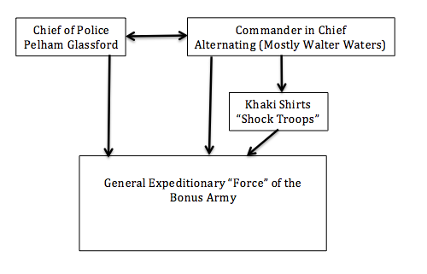
Figure 1 - Power structure of the BEF. As per military tradition, Walter Waters was elected Commander-in-Chief. He ran the Bonus Army in a proto-fascist fashion using elite “shock troops” and was even nicknamed “Mussolini Waters” (Dickson and Allen 2004, p. 143).

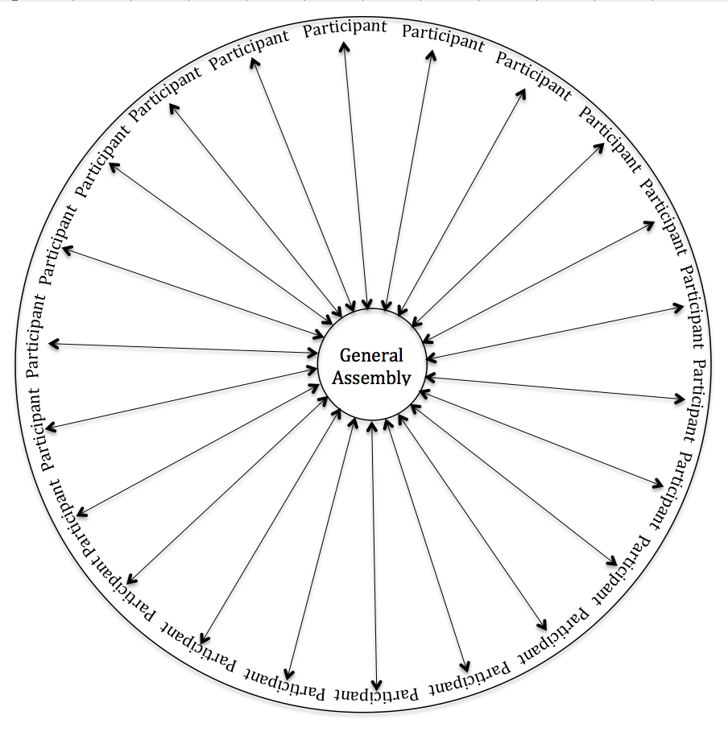
Figure 2 - The General Assembly of OWS. Note that every participant has equal standing and power in this structure in principle and usually in practice.

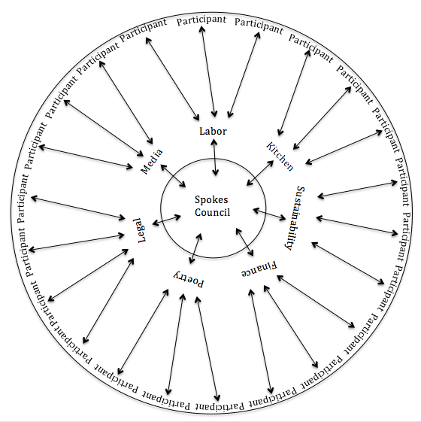
Figure 3 - The Spokes Council of OWS. This Council was designed to allow working groups the freedom to brainstorm or produce work independently of the GA. Members of each working group were often present at larger council meetings, where they sat behind and conferred with their representative. In practice, many of the interest groups overlapped in mission or work, and their recommendations were frequently swept aside once brought to the full GA. Note: only a few randomly selected working groups out of many are presented here.
References
99%, Writers for the. 2011. Occupying Wall Street: The Inside Story of the Action that Changed America. New York: OR Books.
Anglin, Roland V. 2012. "Whose Voice: The Limited Participation of People of Color in the Occupy Movement." in Beyond Zuccotti Park: Freedom of Assembly and the Occupation of Public Space edited by Ron Shiffman, Rick Bell, Lance Jay Brown, and Lynne Elizabeth. Oakland, CA: New Village Press.
Barber, Lucy G. 2002. Marching on Washington: The Forging of an American Political Tradition. Berkeley: University of California Press.
Daniels, Roger. 1971. The Bonus March: An Episode of the Great Depression. Westport, CT: Greenwood Publishing Corporation.
Dickson, Paul, and Thomas B. Allen. 2004. The Bonus Army: An American Epic. New York: Walker & Company.
Franck, Karen A., and Te-Sheng Huang. 2012. "Occupying Public Space, 2011: From Tahrir Square to Zuccotti Park." in Beyond Zuccotti Park: Freedom of Assembly and the Occupation of Public Space edited by Ron Shiffman, Rick Bell, Lance Jay Brown, and Lynne Elizabeth. Oakland, CA: New Village Press.
Freeman, Jo. 1972. "The Tyranny of Structurelessness." Berkeley Journal of Sociology 17:151-63.
—. 1999. "On the Origins of Social Movements." in Waves of Protest, edited by Jo Freeman and Victoria Johnson. Lanham, MA: Rowman and Littlefield.
—. 1999. "A Model for Analyzing the Strategic Options of Social Movement Organizations." in Waves of Protest, edited by Victoria Johnson and Jo Freeman. Lanham, Maryland: Rowman and Littlefield Publishers.
Gamson, William A. 1990. The Strategy of Social Protest. Belmont, California: Wadsworth Publishing Company.
Gitlin, Todd. 2003. The Whole World is Watching: Mass Media and the Unmaking of the New Left: University of California Press.
—. 2012. Occupy Nation: The Roots, The Spirit and The Promise of Occupy Wall Street. New York: Harper Collins.
Harvey, David. 2005. A Brief History of Neoliberalism. New York: Oxford University Press.
—. 2012. Rebel CIties: From the Right to the City to the Urban Revolution. New York: Verso.
Hofstadter, Richard, and Michael Wallace. 1970. American Violence: A documentary History. New York: Alfred A. Knopf.
Juris, Jeffrey. 2008. Networking Futures: The Movements Against Corporate Globalization. Durham, NC: Duke University Press.
—. 2012. "Reflections on #Occupy Everywhere: Social media, public space, and emerging logics of aggregation." American Ethnologist 39(2):259-79.
Kim, Richard. 2011. "We Are All Human Microphones Now." in Richard Kim at The Nation, edited by The Nation. http://www.thenation.com/blog/163767/we-are-all-human-microphones-now#.
Maher, Daniel B. 1932. "One Slain, 60 Hurt as Troops Rout B.E.F. With Gas Bombs and Flames." Pp. 3 in The Washington Post. Washington, D.C.
McAdam, Doug. 1983. "Tactical Innovation and the Pace of Insurgency." American Sociological Review 48(6):735-54.
Meisel, Henry Otto. 1932. Bonus Expiditionary Force: The True Facts. Clintonville, WI: privately printed.
Miller, Frederick D. 1999. "The End of SDS and the Emergence of Weatherman: Demise through Success." in Waves of Protest, edited by Jo Freeman and Victoria Johnson. Lanham, Maryland: Rowman and Littlefield Publishers.
Shiffman, Ron, Rick Bell, Lance Jay Brown, and Lynne Elizabeth. 2012. Beyond Zuccotti Park: Freedom of Assembly and the Occupation of Public Space. Oakland, CA: New Village Press.
Tarrow, Sidney. 2005. The New Transnational Activism. New York: Cambridge University Press.
Taylor, Verta, and Nancy E. Whittier. 1999. "Collective Identity in Social Movement Communities: Lesbian Feminist Mobilizations." in Waves of Protest, edited by Victoria Johnson and Jo Freeman. Lanham, Maryland: Rowman and Littlefield Publishers.
Tilly, Charles. 2006. Regimes and Repertories. Chicago: University of Chicago Press.

It is worth noting that Walter W. Waters published a biographical book on the BEF a year after the expulsion. This, however, I deemed too one-sided and politicized a source. The book by Writers for the 99%, in comparison, was written by committee and therefore likely more representative of the OWS experience.
Inspired by the bravery of OWS activists, many branded Occupys took root across the United States and the rest of the world. Like OWS, their activism faded slowly as winter uprooted many encampments. As of this writing, however, there are still a few active local groups still engaged - Occupy Oakland and Occupy Portland are some examples.
At the time the BEF marched into Washington, D.C. it was a far smaller city than today. The Veteran set up only a few miles from the White House, yet it was undeveloped, open field.
Arrows indicate the flow of power and influence.

